Sussex Safeguarding Adults Boards

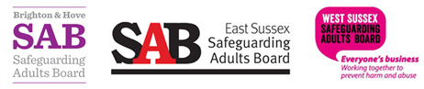

Safeguarding Adult
Review Protocol

This protocol will assist professionals to decide when to refer a case for consideration as a Safeguarding Adult Review, as well as providing guidance on the Safeguarding Adult Review process itself.

Contents Page

- Introduction 4

- Purpose 4

3. Criteria for a Safeguarding Adult Review 5

4. Procedure for making a referral for a Safeguarding Adult Review 5

5. Procedure for undertaking a Safeguarding Adult Review 5

6. Interface with other proceedings or investigations 6

7. Methodology 8

8. Governance 8

9. Timescales 9

10. Responsibilities to the individual(s) and family or carers 9

11. Responsibilities to staff 10

12. The report 10

13. Media, communication and publication 10

14. Implementation and evaluation 11

15. Review 11

Appendices

APPENDIX 1: Referral Checklist 13

Form A – Referral Form 15

APPENDIX 2: Summary of Involvement 18

APPENDIX 3: SAR Methodology Options 21

APPENDIX 4: Roles when using an IMR approach 27

APPENDIX 5: Terms of Reference Template 28

APPENDIX 6: IMR Letter Template 29

APPENDIX 7: IMR Template and chronology 30

APPENDIX 8: IMR Overview Report Template 42

APPENDIX 9: IMR Executive Summary Template 45

APPENDIX 10: Systems Methodology 47

APPENDIX 11: Systems Letter Template 52

APPENDIX 12: Letter to family template 54

APPENDIX 13: Guidance for Families on SARs 55

APPENDIX 14: SAR flowchart 56

- Introduction

1.1 The Care Act 2014 placed a statutory duty on Safeguarding Adults Boards to undertake Safeguarding Adult Reviews (SARs). https://www.gov.uk/government/publications/care-act-statutory-guidance/care-and-support-statutory-guidance

1.2 This Safeguarding Adult Review (SAR) protocol has been developed by Brighton and Hove Safeguarding Adults Board, East Sussex Safeguarding Adults Board and West Sussex Safeguarding Adults Board; and is part of the Sussex Safeguarding Adult procedures.
http://sussexsafeguardingadults.procedures.org.uk/

1.3 The protocol will assist professionals to decide when to refer a case for consideration as a Safeguarding Adult Review, as well as providing guidance on the Safeguarding Adult Review process itself.

- Purpose

2.1 The purpose of having a Safeguarding Adult Review is not to reinvestigate or to apportion blame, it is to:

- establish whether there are any lessons to be learnt from the circumstances of the case, about the way in which local professionals and agencies work together to safeguard adults,
- review the effectiveness of procedures,
- inform and improve local inter-agency practice,
- improve practice by acting on learning, and,
- highlight good practice.
5
2.2 Safeguarding Adult Reviews are not disciplinary proceedings, and should be conducted in a manner which facilitates learning and appropriate arrangements must be made to support staff.

2.3 Safeguarding Adult Reviews are not enquiries into why an adult has died (or been significantly injured), or who is culpable. These are matters for criminal courts and coroner’s courts.

- Criteria for a Safeguarding Adult Review

3.1 A Safeguarding Adult Review (SAR) should always be considered if:

- an adult has died (including death by suicide), and abuse or neglect is known or suspected to be a factor in their death;
or
- an adult has experienced serious abuse or neglect which has resulted in: permanent harm, reduced capacity or quality of life (whether because of physical or psychological effects), or the individual would have been likely to have died but for an intervention;
and
- there is concern that partner agencies could have worked more effectively to protect the adult.

3.2 Safeguarding Adults Boards (SABs) may also arrange for a SAR in any other situation which involves an adult, in its area, with needs for care and support.

3.3 If the SAR criteria are not met but the Board feels there are lessons to be learnt an alternative review may be undertaken. Please see section 6.

- Procedure for making a referral for a Safeguarding Adult Review

  - The Safeguarding Adults Board is the only body that can undertake a Safeguarding Adult Review.

  - Any professional can make a referral for a Safeguarding Adult Review.

4.3 Staff will usually find it helpful to discuss their concerns with their organisation’s safeguarding lead prior to making a referral. Using the referral checklist (Appendix 1).

4.4 Referrals are made via secure email. See referral form A.

4.5 Discussions regarding the appropriateness of referring a case are welcomed by the Safeguarding Adults Board Manager.

- Procedure for undertaking a Safeguarding Adult Review

5.1 Once a referral is received, the Chair of the Safeguarding Adult Review subgroup, supported by the Safeguarding Adults Board Manager, will discuss with members of the subgroup to consider whether the criteria are met.

5.2 Agencies can be asked for additional information by the Board Manager in order to inform this decision. Please refer to Appendix 2.

5.3 The Chair of the Safeguarding Adults Board is responsible for deciding whether to undertake a review or not, based on the recommendations of the Safeguarding Adult Review subgroup.

5.4 The methodology for undertaking a SAR will be discussed and agreed by the subgroup and the Chair of the Safeguarding Adults Board. Please refer to Appendix 3.

5.5 The Safeguarding Adults Board Manager or Chair of the SAR subgroup will inform the referrer in writing of the decision. If the decision is to undertake a SAR, the Board will make arrangements to notify the individual, their family or carers (where appropriate), partner agencies of the Board and the Care Quality Commission (regulator of health and social care services) if registered services are involved.

5.6 When a decision is made to undertake a SAR, a SAR Panel will be convened.

- Interface with other proceedings or investigations

6.1 It may be necessary to consider whether the case meets the criteria for other multi-agency reviews.

6.2 The Board acknowledges that the following are statutory:

- Serious Case Reviews concerning children https://sussexchildprotection.procedures.org.uk/

- Domestic Homicide Reviews https://www.gov.uk/government/collections/domestic-homicide-review

- MAPPA Serious Case Reviews https://www.justice.gov.uk/downloads/offenders/mappa/mappa-guidance-2012-part1.pdf

- Mental Health Homicide Reviews https://www.england.nhs.uk/publications/reviews-and-reports/invest-reports/

- Serious Incident
https://www.england.nhs.uk/patientsafety/wp-content/uploads/sites/32/2015/04/serious-incidnt-framwrk-upd2.pdf

6.3 The Learning Disabilities Mortality Review (LeDeR) Programme is a National Programme which reviews all deaths of people with a learning disability, aged 4 years and over. There are LeDeR Local Area Contacts in each Local Authority. LeDeR is not a statutory process, but is an NHS ‘Must Do’ and a national priority. It does not replace the SAR process, but can run concurrently with a SAR. A LeDeR may trigger a statutory process if multi-agency learning needs are identified for the local area. Each Board should have in place appropriate links between the LeDeR and the SAB so as learning to improve adults with care and support needs is shared. Business Managers and the LeDeR Local Area Contact should ensure practical arrangements for running reviews concurrently are taken into consideration at the commencement of reviews, particularly where this involves family involvement and access to patient records.

6.4 There may be criminal or coronial investigations running concurrently with the Safeguarding Adult Review. Steps need to be taken to ensure the adult is safe, and any proposals for review must ensure the SAR does not prejudice criminal or judicial proceedings.

6.5 In some cases, criminal proceedings may follow the death or serious injury of an adult. The SAR subgroup Chair should discuss how the review process should take account of such proceedings with the relevant criminal justice agencies (such as the police and the CPS) at an early stage. Consideration should be given to, for example, effects on timing, the way in which the review is conducted (including any interviews of relevant personnel), what the potential impact on criminal investigations is and who should contribute at what stage? Work to understand and learn from the case can often proceed without risk of contamination of witnesses in criminal proceedings.

6.6 It may also be necessary to delay the publishing of overview reports until the conclusion of any criminal trial. Individual agencies can however progress with implementing the learning from the review.

6.7 It is also acknowledged that all agencies will have their own internal or statutory review procedures to investigate serious incidents. This protocol is not intended to duplicate or replace these and any opportunities to prevent duplication will be encouraged.

6.8 In some cases, dependent on the specific issues in the case, internal
investigation reports may provide adequate information to address the terms of reference; or it may be that additional reports are required to address any outstanding areas. Careful planning and communication is required to make the most effective use of resources and avoid duplication.

6.9 Safeguarding Adult Reviews are not part of any disciplinary process. However, should information emerge in the course of the Safeguarding Adult Review that may indicate that disciplinary action should be taken; the agencies concerned should deal with such issues in accordance with their own procedures. If disciplinary matters are in progress at the commencement of the Safeguarding Adult Review these should be notified to the Board Manager.

- Methodology

7.1 Safeguarding Adult Reviews can be conducted in a variety of ways. Traditional methods involve analysis of the involvement of agencies, led by an independent overview report author. With this method individual agencies are asked to review the practice within their organisation through Individual Management Reviews (IMR) and Chronologies which then form part of an Overview Report. Please see Appendix 7.

7.2 More recently, ‘systems learning’ (i.e. a model introduced by the Social Care Institute for Excellence following the Munro Review of Child Protection published in 2011) has been introduced as an alternative method. This approach sets out to study the whole system and look closely at what influenced professional practice. It does this by taking account of the many factors that interact and influence individual worker’s practice in a more in-depth way. The process seeks to be collaborative with professionals being actively involved in the review from the outset. Please see Appendix 10.

7.3 The Safeguarding Adults Board will endorse the approach best suited to the circumstances of each individual case, and the SAR subgroup will decide on the most appropriate method. Please see Appendix 3 – SAR methodology.

- Governance

8.1 Safeguarding Adult Reviews are overseen by the Safeguarding Adults
Board, which is a multi-agency partnership with senior manager representation from all the key agencies. The Board is responsible for ensuring that effective systems are in place for the completion of Safeguarding Adult Reviews, including:
- decision making in respect of undertaking reviews,
- formally accepting reports, and
- agreeing sign off of the report for publication.

Please see Appendix 4 and 10.

8.2 Responsibility for the management of Safeguarding Adult Reviews is delegated to the SAR subgroup. This group is responsible for the effectiveness of the SAR Panel to ensure timely completion of reviews. The SAR subgroup will keep the Board updated and make recommendations as required.

8.3 Safeguarding Adult Reviews will be presented to the Board on completion.

8.4 Involved organisations will be provided with copies of reports for comments on factual accuracy prior to the final draft. Where a Safeguarding Adult Review Panel is established it will be the role of the Panel to ensure the report is factually accurate and based on the evidence gathered during the process.

8.5 All involved agencies will be asked to participate in identifying solutions to any recommendations of the review to support improvements in practice.

8.6 Boards and organisations should co-operate across borders, and requests for the provision of information should be responded to as a priority – see ADASS Safeguarding Adults Policy Network Guidance: https://www.adass.org.uk/media/5414/adass-guidance-inter-authority-safeguarding-arrangements-june-2016.pdf

- Timescales

9.1 Safeguarding Adult Reviews must be completed in a timely manner.

9.2 Once the decision to undertake a Safeguarding Adult Review has been made, it is good practice for it to be completed within six months.

9.3 It is acknowledged that where there are dual processes or reviews that are complex, these may require more time. Any urgent issues which emerge from the review and need to be considered without delay should be brought to the attention of the Board.

- Responsibilities to the individual (s) and family or carers

10.1 It is important that consideration is given to the best means of notifying the individual(s) (where possible), and their relatives and carers (where appropriate) that a review is being undertaken. Please see Appendix 12.

10.2 Individual(s) will be notified that the review will look at records and notes held by public bodies, including adult social care and health providers.

10.3 Where appropriate, the Board will make arrangements for the individual(s) and / or their family and carers to participate in the Safeguarding Adult Review. Their consent is not required for the review to go ahead. Please see Appendix 13.

10.4 Individual(s) and / or their families and carers should be kept updated at key stages of the review and notified of the publication of the report.

- Responsibilities to staff

11.1 The staff directly involved in the care and support of individuals subject to a Safeguarding Adult Review should be notified of the decision to undertake a Safeguarding Adult Review, and there is an expectation that support will be provided to them by their agency. The process and their involvement should be fully explained.

11.2 At the end of the process staff will be invited to share their experiences and give feedback on the process.

- The report

12.1 In compiling the SAR report, it should:
- provide a sound analysis of what happened,
- contain findings or recommendations of practice value to organisations and professionals, and
- be written in plain English.

Please see Appendix 8.

12.2 Where appropriate, arrangements will be made to share the report and its findings with the individual(s), and / or their family and carers.

12.3 Where possible and practicable the individual(s) and / or family and carer will be consulted with to agree how the person(s) in the review will be referred to.

12.4 The final report will be signed off by the SAB.

- Media, communication and publication

13.1 The SAR subgroup Chair, in consultation with the SAB Chair, will consider appropriate publication of the report on a case by case basis. Discussions about publication will be held with the individual(s), their family or carers (where appropriate).

13.2 Since Adult Social Care is the lead agency, media and communication issues will usually be co-ordinated by the council’s Communications Team. This will be done in collaboration with the communications teams of the other agencies involved, alongside agreed representatives of the Board.

13.3 All SAR reports will be considered for publication on the website of the relevant Safeguarding Adults Board. In the case of publication, the Chair of the Safeguarding Adults Board will release a statement where appropriate.

- Implementation and evaluation

14.1 The real value of the completion of a Safeguarding Adult Review is to ensure that the relevant lessons have been learnt and that professional multi-agency safeguarding is improved, in order to prevent the issues in question happening again.

14.2 The SAR subgroup will consider the recommendations from the report and agree an action plan (if required).

14.3 The SAR subgroup will be responsible for ensuring the implementation of the action plan, monitoring the progress made and making links with relevant subgroups of the Board as required.

14.4 Following the completion of a SAR, learning will be cascaded through single and multi-agency learning and development opportunities and SAB bulletins.

- Review

15.1 There will be a formal annual review of this protocol to take account of developments and new legislative requirements.

APPENDICES

Please note these are suggested templates

APPENDIX 1: Referrer Checklist and Guidance - for making a Safeguarding Adult
Review referral.

When making a SAR referral you may find the following checklist helpful in discussion with your agency’s Safeguarding Adults Lead:

Question or consideration | Yes/No/ | Comments
Has the adult(s) died?
Has the adult(s) suffered significant harm?
Is there clear evidence of a risk of significant harm to an adult?
Was the harm recognised by agencies or professionals in contact with the adult or perpetrator?
Was information shared with others?
Did agencies or professionals act upon the information appropriately?
Was the adult abused in a care setting?
Did any agency or professional consider their concerns were not taken sufficiently seriously, or acted upon appropriately, by another?

Does the case indicate that there may be failings in one or more aspects of the local operation of formal safeguarding adults’ procedures, which go beyond the handling of this case?
Does the case appear to have implications for a range of agencies and/or professionals?
Does the case suggest that the SAB may need to change its local protocols, procedures; or that protocols and procedures are not adequately being publicised, understood or acted upon?
Are there any exceptional circumstances e.g. good practice learning, significant political or media interest?
If the adult was living with a Learning Disability and has died, has a LeDeR notification been completed?

Referrer Guidance:

All SAR requests will be assessed by the SAR subgroup in accordance with the Sussex Safeguarding Procedure/Guidance for conducting Safeguarding Adult Reviews.

Please include as much information as possible and answer each question giving details of:

- the name(s) and date(s) of birth of the victim(s) (if known);
- name of any service provider involved;
- local authority involved in the safeguarding adults case;
- name of the Safeguarding Adults Co-ordinating Manager and/or the Chair of any safeguarding meeting (if known) and
- details of why, in the referrer’s opinion, the case meets the Safeguarding Adult Review criteria and guidelines contained in paragraph 3 of the protocol, specifically linking the referred to the criteria.

Please note that the report should not exceed 3 sides of A4 paper. If any additional information is required you will be contacted.

Form A
SAR Referral Form
REFERRAL INFORMATION
NAME OF PERSON MAKING THE REFERRAL
NAME OF YOUR AGENCY
YOUR POSITION
YOUR EMAIL ADDRESS
YOUR ADDRESS
YOUR CONTACT NUMBER

DETAILS OF PERSON BEING REFERRED FOR A SAR
NAME OF PERSON BEING REFERRED
DATE OF BIRTH
Next of Kin
DATE OF INCIDENT OR ISSUES
Is the person deceased or alive?
Has the person or family member been informed of the SAR referral?

AGENCIES INVOLVED | KEY CONTACT NAME | CONTACT DETAILS | Has the agency been informed about the SAR referral?

REASON FOR REFERRAL – PLEASE DO NOT EXCEED 3 SIDES OF TEXT
Please refer to the Sussex Safeguarding Adults Policy and Procedure Manuel; http://sussexsafeguardingadults.procedures.org.uk/hkyly/appendices/appendix-2-roles-and-responsibilities-safeguarding-adults-board-functions-and-safeguarding-adults-reviews and consider if your referral meets the following criteria:
- SABs must arrange a SAR when an adult in their area dies as a result of abuse or neglect whether known or suspected, and there is concern that partner agencies could have worked more effectively to protect the adult.

- SABs must also arrange a SAR if an adult in its area has not died, but the SAB knows or suspects that the adult has experienced serious abuse or neglect. In the context of SARs, something can be considered serious abuse or neglect where, for example the individual may likely have died had it not been for an intervention or has suffered permanent harm or reduced capacity or quality of life (whether because of physical or psychological effects) as a result of the abuse or neglect. SABs are free to arrange for a SAR in any other situations involving an adult in their area with needs for care and support.

- The SAB should be primarily concerned with weighing up what type of ‘review’ process will promote effective learning and improvement action to prevent future deaths or serious harm occurring again. This may be where a case can provide useful insights into the way organisations are working together to prevent and reduce abuse and neglect of adults.

SARs may also be used to explore examples of good practice where this is likely to identify lessons that can be applied to future cases.

Insert your summary here:

Completed by
Signed
Date
For the attention of:
For Brighton & Hove:
Laura Perkins, LSCB & SAB Business Manager
Tel: 07584 217290
Email: SafeguardingReviews@brighton-hove.gov.uk

For East Sussex:
Delyth Shaw, Interim SAB Development Manager
Tel: 01273 335641
Email: delyth.shaw@eastsussex.gov.uk or delyth.shaw@eastsussex.gcsx.gov.uk

For West Sussex:
David Feakes – Chair of the Safeguarding Adult Review Subgroup
Email: safeguardingadultsboard@westsussex.gov.uk
(NB: Confidential information should be password protected and the password e-mailed separately)
To be completed by Board Manager
Da Date SAR referral was discussed:
f SAR criteria met: | Y | g SAR criteria not met:
Date sent to Independent Chair: |  | Date Independent  Chair approved  Referral:
Rationale for decision and proposed methodology:
Comments from Independent Chair:

Please note these are suggested templates

APPENDIX 2 – Summary of Involvement
Summary of Involvement:
The information requested on this form will be used for the purpose of deciding whether the criteria for holding a Safeguarding Adults Review have been met.
The form is sent out to all agencies, you are asked to complete only those questions on which you hold information or indicate that this person and their family were not known to your services.
This pro-forma should be completed by the Lead Safeguarding Adult’s professional in your organisation and sent to: Head of Adult Safeguarding, Adult Social Care & Health

Please ‘password protect’ this document.

Name of Agency :

Name and Job Title of Lead Safeguarding Adults Professional:
Contact Telephone Number:

Email:

Name Of Adult(s): (completed by SAB)

Date of Birth: (completed by SAB)

NHS/Framework/ID Number(s): (completed by SAB)

Address(es) known: (please add any other addresses on your records)

Timeframe identified for Review: (completed by SAB)

Summary of Case: (completed by SAB)
Agency relationship with Adult:
Date when your involvement with the adult started:

Date when your involvement with the adult ceased:

PLEASE COMPLETE AND RETURN TO XXX no later than

(INSERT DUE DATE)

Agency: |  |  | Person identified for completing IMR and chronology should a review be undertaken:  (and e-mail)
Factual summary of agency involvement:

Provide a brief factual and contextual summary of your agency’s involvement with the adult for the time period identified for this Safeguarding Adult Review. Note the following key information:
- significant events, attendance at appointments;
- involvement of other agencies/friends/family (with contact info where possible);
- changes in level of need/engagement with agencies and
- referrals of concerns, and how these were received by other agencies.

(Additional sections of the table can be added if required by clicking on ‘Layout’ and then ‘Insert Below’)
Date: |  | Summary of Involvement |  |  |  | Follow-up?
List details of front line staff and manager working with individual:
Name: |  |  |  | Position:
Other known agencies working with the individual e.g. local voluntary services:
Organisation: |  |  |  | Contact (if known):
Details of any concerns about the adult/carer and the actions taken by the agency:

I confirm that this is an accurate Summary of Involvement in line with the Sussex Safeguarding Adults Review protocol.

Signed:__________________________________________ Date:__________________________

Job Title:_________________________________________
Please ensure that all information requested above has been passed to Senior managers within your agency prior to returning to the Safeguarding Adults Board.

Appendix 3 - SAR METHODOLOGY OPTIONS

When it is concluded that a Safeguarding Adult Review is appropriate, the subgroup should draw up an outline for the conduct of the review and identify the most appropriate methodology for the review. A Safeguarding Adult Review can be conducted by adopting a more traditional panel approach or a systems based review with lead reviewers.

- The menu of SAR methodologies set out below includes the following six options:

  - systems analysis;
  - learning together;
  - significant incident learning process;
  - significant event analysis/ audit;
  - appreciative inquiry or
  - hybrid approach.

- On the following pages, a process map of each methodology is provided, along with key features and advantages and disadvantages to assist decision-making. Links are provided to the above identified models, which can be used for the most part to download tools and guidance in order to conduct a SAR according to the methodology.

- The menu is not an exhaustive list. The Chair of Safeguarding Adults Review subgroup with its members should use its collective experience and knowledge to recommend the most appropriate learning method for the case (including hybrid approaches).

- Once a methodology has been selected, all SAR panel members and others participating in a SAR will be fully briefed on the methodology to support them in carrying out their role. SAR panel chairs must not be too rigid or constrained by the methodology chosen – chairs may allow a degree of flexibility within each methodology, allowing SAR panel members to do things slightly differently, where appropriate, in order to secure the maximum learning and benefit from the review.

- Regardless of the methodology selected, all SARs should be completed within six months unless there are extenuating circumstances (e.g. potential to jeopardise police or court proceedings). SAR panel members should try to agree an appropriate timescale for the Review at the outset.

Considerations should include:
- What appears to be the most important issues to address?
- Has or is it likely that the case has given rise to other parallel investigations (e.g. disciplinary, criminal, regulatory, health & safety, Coroner’s Inquiry, Child Protection, Domestic Homicide Review) and if so, how can a coordinated review process best address all the relevant questions in the most efficient way? Who do the reviewers need to liaise with?
- Does the scope of the review indicate the need to obtain independent legal advice about any aspect of the proposed review?
- Where there could be the possibility of a review and a serious incident running concurrently, consideration should be given at the planning stage of how to link relevant elements of the investigations to avoid duplication; satisfying both requirements.
- Where appropriate, the reviewers to agree an inter-agency media strategy and consider who else at a senior level needs to be informed in each organisation.

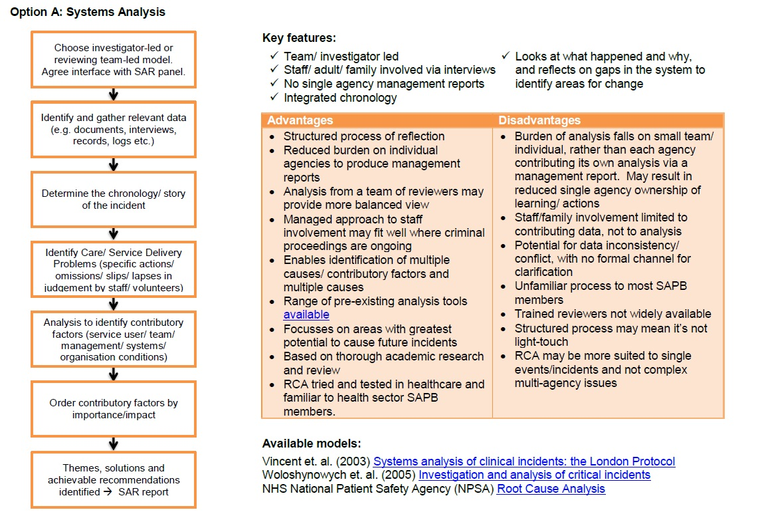

Option B
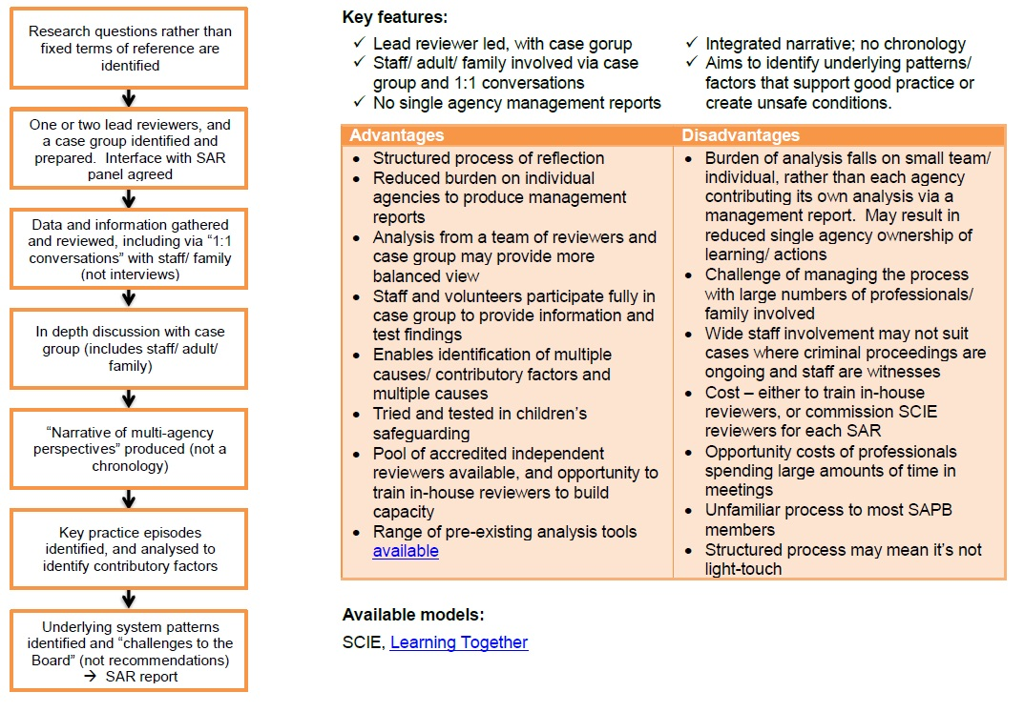

Option C
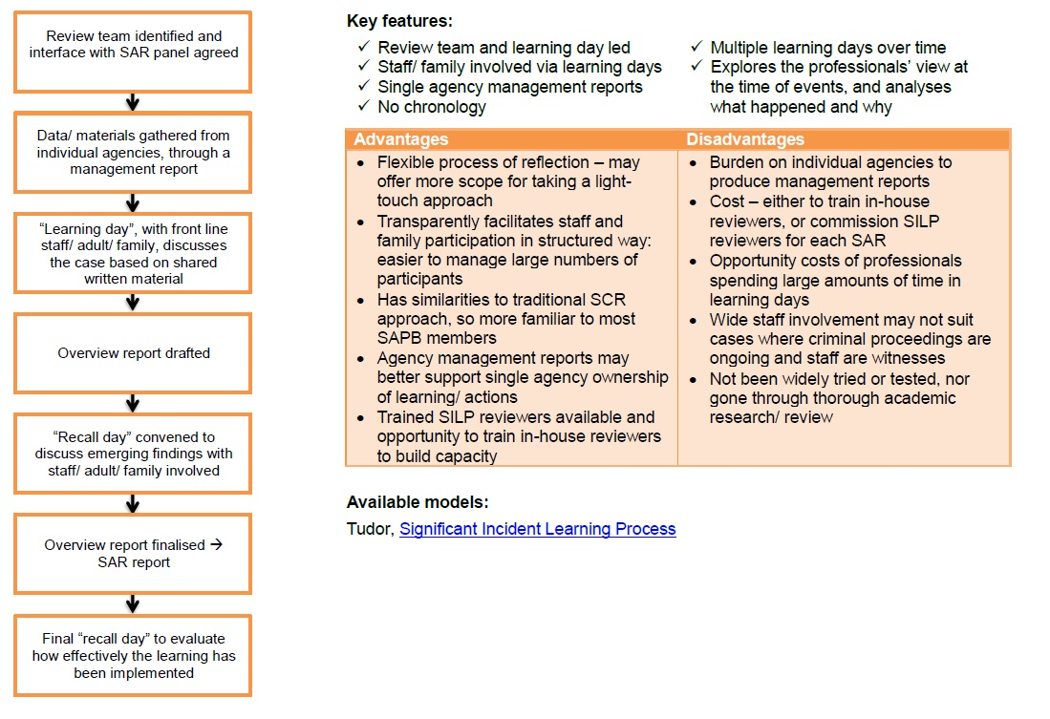

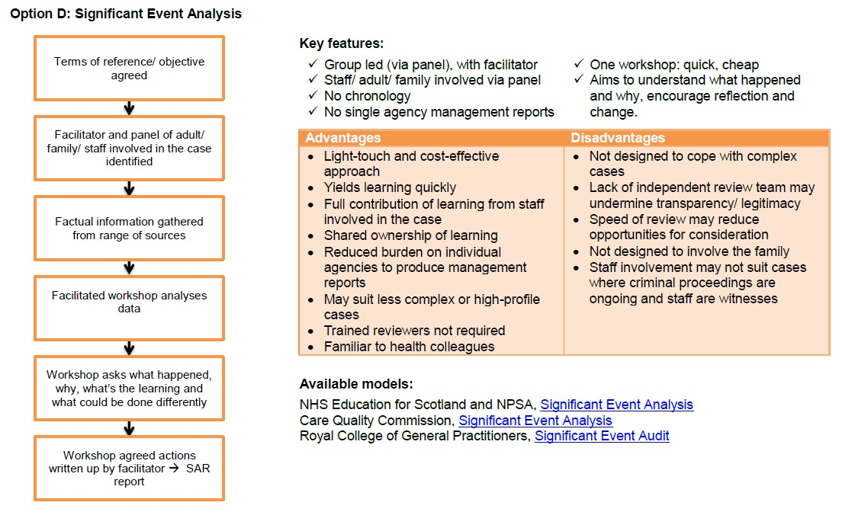

APPENDIX 4 - Roles when using an IMR approach

These are the individual roles that are usually expected when undertaking SARs:

Chair of Safeguarding Adults Board

- Retains strategy oversight of the SAR process
- Supports the SAB to fully consider the merits of a referral
- Assist in arbitrating issues that are problematic; enable the SAB to understand the findings of a SAR

Chair of SAR Subgroup

- Receives SAR referral
- Arranges subgroup consideration
- Refers to the SAB Independent Chair
- Acts as intermediary between SAR subgroup and SAB
- Senior point of reference for SAR panel
- Oversees SAR recommendations, implement and monitor action plan to achieve recommendations

Oversight Report Author

- Leads overview of SAR review
- Agrees final Terms of reference to share with panel
- Link to relevant agencies
- Writes SAR report
- Proposes SAR recommendations
- Presents to SAB

Independent Chair SAR Panel

- Leads overview of SAR review
- Links to relevant agencies
- May write the SAR report
- May propose SAR recommendations
- May present to SAB

Board Manager

- Enables practical delivery of SAR Panel process
- Acts as intermediary between SAR subgroup, Oversight Report Author and the SAR Panel
- Liaises with individual(s) and / or family members where appropriate

Please note these are suggested templates

Appendix 5 – Suggested Safeguarding Adult Review Terms of Reference template

The Safeguarding Adults Review subgroup will draft Terms of Reference for each Safeguarding Adult Review.

These will be confirmed with the Independent Overview Report Author alongside the SAR Panel. These may be shared with the individual(s) and / or family members to review and finalise, where appropriate.

The purpose of the Review is to establish whether there are lessons to be learnt from the circumstances of the case about the way in which relevant professionals and agencies have or are working together to safeguard adults to inform inter-agency and multi-agency practices as they relate to safeguarding adults.

The Terms of Reference may include:

- details of the person(s) subject to the Safeguarding Adult Review – name, date of birth, date of death (if relevant), address;
- brief details of the concern that triggered the Safeguarding Adult
Review;
- specific areas of concern for the Safeguarding Adult Review to focus upon;
4. period of time the Safeguarding Adult Review is to consider;
5. agencies to provide Chronologies and Individual Management Reviews;
6. membership of Safeguarding Adult Review Panel – agencies, experts and specialists;
7. Chair of the Safeguarding Adult Review Panel;
8. Independent Overview Report Author;
9. strategy for involvement of family members;
10. reference to any parallel investigations;
11. start and completion dates for the Safeguarding Adult Review;
12. areas to be analysed;
13. strategy for implementation of lessons learnt;
14. a strategy for publication of the Overview Report and Executive
Summary and
15. a strategy for managing media interest.

Please note these are suggested templates

Appendix 6 – Suggested IMR Template Letter requesting IMR and nominations to the Safeguarding Adults Review Panel

Dear

Re:

Name:
DOB:
Address:

I am writing to inform you that the Safeguarding Adults Board has decided that a Safeguarding Adult Review will be undertaken. It will investigate and review the involvement of agencies into the health and social care support received by xx prior to her/his death. I enclose Terms of Reference for the review.

The Safeguarding Adult Review Panel will be chaired by an independent person and will require a representative from your agency. I would be grateful if you could nominate a suitable representative with suitable seniority and experience.

A separate suitably experienced officer should be identified to undertake the Individual Management Review into this case as required under the Safeguarding Adult Review protocol. The Individual Management Review author should have no line management relationship with practitioners working with the adult or any direct contact themselves with the adult.

In accordance with the Safeguarding Adult Review protocol, please can you ensure that your agency files in respect of the above named adult are immediately secured to guard against potential loss or interference, and to enable the Safeguarding Adult Review process to commence.

I attach information and a template relating to the Individual Management Review and in relation to the chronology which your agency is required to complete. There will be an introductory meeting for Individual Management Review authors to explain the process once we have the details.

The findings from the Individual Management Review should be agreed and accepted by you as the senior officer in the organisation, who has responsibility for ensuring that the recommendations are acted upon.

I would be obliged if you could confirm your Individual Management Review author and nominated panel representative to xxx, the Board Manager.

Yours sincerely

Chair of the Safeguarding Adults Board

Please note these are suggested templates

Appendix 7 – Suggested Template forms for completing an Individual Management Review and Chronology

Introduction

The following (Forms C to K [note there is no ‘Form I’]) are a set of templates that combined form an Individual Management Review (IMR). This details an agency’s involvement and sets out their relationship to the person(s) under consideration.
These templates are to be fully completed by each agency that has been involved with the person(s) subject to the SAR, and have been asked to do so by the SAR subgroup. They record the decisions, actions taken and services provided to the person(s) who is subject of a Safeguarding Adult Review.

- The aim of the IMR is to look openly and critically at individual and organisational practice. The IMR will indicate what changes could and should be made and, if so, to identify how those changes will be brought about.

- The findings from the IMR report should be endorsed by the Senior Responsible Officer within the organisation who has commissioned the IMR and who will be responsible for ensuring that recommendations are acted upon.

The IMR provides a chronology of agency involvement and draws overall conclusions from the involvement with that agency.

The completed IMR should be returned to:

Independent Chair/Author
Email:

IMR SECTION 1

Form C: IMR SUMMARY AND IDENTIFYING INFORMATION

Name of agency

Name of Lead Person Completing IMR and Chronology:

Address:

Contact telephone number:

Email:

Name of adult(s):

Date when your involvement with the adult(s) started:

Date when your involvement with the adult(s) ceased:

Factual summary of agency involvement:
Provide a brief factual and contextual summary of your agency’s involvement with the adult(s) for the time period identified for this Safeguarding Adult Review

IMR SECTION 2

Form D: IMR CHRONOLOGY OF AGENCY INVOLVEMENT

Notes: What was your agency’s involvement with this adult(s)? Construct a comprehensive chronology of involvement by your agency and/or professional(s) in contact with the adult(s) over the period of time set out in the review’s Terms of Reference. The information which is required under each heading should be fairly self-explanatory. The last column “comment” should be used if the agency reviewer wishes to comment on the appropriateness/quality of the intervention, or whether it raises any other professional issues.

It is important that you insert the date to facilitate merging with chronologies from other agencies and that nothing else is entered in the date column. Where abbreviations are used, please provide a glossary at the back of this document to explain them.

Name of agency:

Name(s) of adult(s):

Ethnic origin:
Dates covered by the chronology:

Date | Source of Evidence | Contact with (initials) | Name of professional | Communication / reason/incident/ contact location | Actions taken/  decisions made | Comments
dd/mm/yy

dd/mm/yy

dd/mm/yy

dd/mm/yy

dd/mm/yy

dd/mm/yy

dd/mm/yy

dd/mm/yy

dd/mm/yy

IMR SECTION 3

Form E: IMR LIST OF SUPPORTING DOCUMENTS

Notes: Please list all source documents you have used in completing your Individual Management Review.
Document | Reason/Commentary/Link or Reference

IMR SECTION 4

Form F: IMR ANALYSIS OF INVOLVEMENT

Notes: The agency is expected to rigorously analyse their involvement with their designated report writer, capturing this information. Consider the events that occurred, the decisions made and the actions taken or not. Where judgements were made or actions taken which indicate that practice or management could be improved, try to get an understanding not only of what happened, but why.

Please use the template provided, if a section does not apply to your agency then identify that this is the case in the appropriate box.

Facts should not be stated without their origin and related evidence and any source material should be referenced on Form E.

Consider specifically the following areas (each box is designed as a prompt to add specific information and will expand as you type).

1 SUMMARY: Summarise your analysis of the involvement of your agency with this person(s).

2 POLICY & PROCEDURE: Did your agency have policies and procedures in place for safeguarding adults? Please indicate when these policies were last reviewed.
3 PERSON’S VOICE: Was a relationship established with the individual at the start of the enquiry? How were outcomes agreed and did the person’s wishes remain the focus of the enquiry throughout the process? How did your agency ensure that the person was satisfied with the outcome of the enquiry? If not, how was this recorded? Support/relationship with family/advocate where appropriate?
4 STAFF KNOWLEDGE & AWARENESS - GENERAL AND SPECIFIC: Were all practitioners and managers sensitive to the needs of the person in their work; knowledgeable about potential indicators of abuse or neglect and knew what to do if they had concerns about an adult(s)? Provide evidence.

5 CARE AND SUPPORT PLANNING: Was there a clear plan of care for the person? Did all your practitioners and managers involved in the care and management accord with care arrangements you were required to provide? What is your evidence?

6 PROFESSIONAL STANDARDS: Did all of your practitioners’ and managers’ actions and practices accord with the standards of care that were required to provide; whether that be as per your organisational policy and expectations and/or in accordance with formal professional standards to which their role relates?

7 SERVICES PROVIDED: Were all appropriate services offered and/or provided? Were relevant enquiries made, where necessary in the light of assessments? Evidence

8 ASSESSMENT AND DECISION MAKING: What were the key relevant points and opportunities for assessment and decision making in relation to the adult(s)? Is there evidence that assessments and decisions have been reached in an informed and professional way?
9 SPECIFIC SAFEGUARDING ARRANGEMENTS: Where relevant, were appropriate safeguarding adults or care plans in place and safeguarding adults reviewing processes complied with? Provide evidence.

10 CAPACITY: Was a Mental Capacity Act assessment of the vulnerable adult(s) completed? Was this information recorded? Provide evidence.

11 SENIOR OVERSIGHT AND SCRUTINY: Were more senior managers in your organisation and/or other agencies and professionals appropriately involved at points where they should have been? Did your staff escalate any issues of concern, raise matters of concern with other professionals or seek guidance where necessary?

12 PROCESS AND ACTIONS: Are you satisfied that all the care provided to the individual was satisfactory? After the person had died (if relevant), are you satisfied that all appropriate actions, process and investigations were undertaken to fully determine if the care of the individual had contributed to their death?

13 EQUALITY AND CULTURAL SENSIVITY: Was the practice of all people involved in the care of the adult(s) from your agency sensitive to the racial, cultural, linguistic and religious identity of the adult(s)?

14 ADDITIONAL FACTORS: Are there are any particular features of this case, issues surrounding the death or injury of the adult(s), that you consider require further comment in respect of your agency’s involvement.

IMR SECTION 5

Form G: IMR LEARNING

This section is for you to critically review the case from your perspective and consider any learning from your agency’s perspective or wider learning that the Safeguarding Adults Case Review (SACR) subgroup could consider? The form will expand as you type
1 Has your agency taken forward any lessons from this case that is now implemented to appropriately support adults and/or safeguard them?
2 Is there good practice to highlight, as well as ways in which practice can be improved?
3 Are there implications for ways of working within your agency?
4 Are there implications for training (single or multi-agency)?
5 Are there implications for the management of staff within your agency and/or supervision of staff who work for your agency?
6 Are there implications for working in partnership with other organisations?
7 Are there implications for service provision within your organisation?
8 Are there any other issues, implications or remedial actions for your agency?

IMR SECTION 6

Form H: IMR OVERALL CONCLUSIONS AS A RESULT OF YOUR REVIEW

1 Please provide an overall conclusion of your review

IMR SECTION 7

RECOMMENDATIONS FOR YOUR AGENCY ARISING FROM YOUR REVIEW OF THIS CASE

Notes: Based upon your review and conclusions, please set out the recommendations that you propose for your agency. These should be focused, specific, measurable and capable of being implemented. A view on how these could be achieved should be included. Consideration should be given to the resources required to implement the recommendations.

Recommendations should be divided into:

Review – changed practice that should already be happening (if this has been a previous recommendation include an analysis of why previous actions have failed)

New – actions that need to be introduced and implemented as a result of your review.

Recommendations should also be identified as either:
- Multi-agency and/or
- Single agency.

Form J: RECOMMENDATIONS FOR YOUR AGENCY ARISING FROM YOUR REVIEW OF THIS CASE

Recommendation: Insert here your recommendation

Agency | Lead professional | Action (required or taken) | Timescale | Barrier to implementation | Outcome of action | Progress

Insert more recommendation tables as needed by cutting and pasting.

Guidelines for completing Safeguarding Adult review action plans. Each agency is to identify a lead professional to co-ordinate their agency’s response and their name is to be forwarded and details provided.

a. Name of agency

b. In the lead professional column clearly identify name and role of person.

In the action column indicate what action has been taken to address the recommendation or what action will be taken.

In the timescale column provide the date the action was completed and/or provide a realistic timescale in which your agency will address outstanding action.

In the barrier to implementation column your agency will need to identify any barriers in taking the action forward in your agency.

In the outcome of recommendation column provide a summary of the impact of the recommendation, how the agency has learnt lessons and identify source of evidence to demonstrate learning.

In the progress column state whether action arising from the recommendation is ‘compliant’ ‘progressing’ or ‘non-compliant’.

IMR SECTION 8
Form K: SIGN OFF - AGENCY OWNERSHIP OF INDIVIDUAL MANAGEMENT REVIEW
IMR completed by:

Name:

Position:

Signature:

Date

The undersigned person is the most senior person within your agency who agrees with the IMR as detailed and the recommendations to be taken

IMR Agreed by:

Name
Position
Signature
Date

Please note these are suggested templates

Appendix 8 – Overview Report

Content of report:

- Introduction
- Circumstances that led to a Safeguarding Adult Review being undertaken in this case
- Terms of Reference
- Process of the Safeguarding Adult Review
- Facts of the individual case
- Analysis of individual case
- Conclusions & recommendations
- Recommendations presented in a grid with SMART targets

Introduction
This Overview Report is intended to provide an overview of the deliberations and recommendations of the Safeguarding Adult Review Panel, drawing overall conclusions from the information and analysis contained in the Individual Management Reviews and reports commissioned from any relevant parties.

Describe individual circumstances and reasons for the review being undertaken. List contributors to the review and the nature of their contributions, including from family.

The circumstances that led to a Safeguarding Adult Review being undertaken
in this case
Provide an overview of the specific individual circumstances and outline the concerns to be addressed. Give the specific facts of the Safeguarding Adult Review. State when the Safeguarding Adult Review commenced and the commissioning arrangements details of the Independent Chairperson/Independent Overview Report Author.

Terms of Reference
Detail the agreed Terms of Reference

Process of the Safeguarding Adult Review
Describe the process of the review that is undertaken by the Safeguarding Adult Review Panel. The panel consisted of representatives from (list appropriate agencies).

List agencies that provided Individual Management Reports
State whether family and/or others were included or involved in the process and if not, provide an explanation, for example, criminal proceedings.

Facts of the Individual Case
Compile an integrated chronology of involvement with the adult and family on the part of all relevant agencies, professionals and others who have contributed to the review process. A Chronolator can be used.

Important to include:

- relevant information relating to the adult;
- critical and life incidents;
- features of professional activity over time which should include key events, for example a referral or services provided;
- give an overview which summarises what relevant information was known to the agencies and professionals involved and
- provide an explanation and exploration of ethnicity.

Analysis
This part of the Overview Report should look at how and why events occurred, decisions were made and actions taken or not taken. Identifying the key features of the case:

- adult’s needs/characteristics/behaviour;
- wider family and environment;
- professional involvement and
- analysis of interacting risk and protective factors to include a clear summary and synthesis of the knowledge

Assessment

- A description of the problem/concern
- A description of protective factors and support
- A hypothesis about the nature, origins and cause of the
need/problem/concern, and
- A plan of the proposed decisions and/or interventions

This is the part of the Overview Report which can consider whether different decisions or actions may have led to an alternative course of events.

Communication between and within agencies

- Was there a shared safeguarding agenda between or within agencies?
- Was there evidence that the adult’s needs were paramount?
- Challenge of carer/care provider power.

Reference should be made to the quality of the Individual Management Reviews and how this assisted in analysing how and why events occurred and why some decisions were or were not taken. The Overview Report should challenge agency practice and comment on whether different decisions or actions may have led to an alternative course of events.

The analysis section is also where any examples of good practice should be highlighted.

This part of the Overview Report should take account of recent and well publicised major inquiries and government guidance pertinent to the case.

Conclusions and recommendations
This part of the Overview Report should summarise what the lessons to be drawn are and how those lessons should be translated into recommendations for action.

The Overview Report should make reference to single agency recommendations, identified through the Individual Management Reviews and identify any further single agency recommendations.

Recommendations should be few in number, focused and specific (SMART) and capable of being implemented. View on how these could be achieved should be included. Consideration should be given to the resources required to implement the recommendations, such as cost.

If there are lessons for national, as well as local policy and practice these should also be highlighted.

Action plan
The overall action plan should identify the main cross cutting multi-agency themes.
27

Please note these are suggested templates

Appendix 9 - Executive Summary

Content of report:

- front sheet with anonymised name of the adult with date of birth and date of death or age at the time of the incident;
- introduction;
- circumstances that led to a Safeguarding Adult Review being undertaken in this case;
- Terms of Reference;
- case summary;
- relatives/other relevant persons;
- context of agencies involved, and,
- conclusions and recommendations.

Introduction
This document is intended to provide an overview of the deliberations and recommendations of the Safeguarding Adult Review Panel instigated by the Safeguarding Adults Board relating to xx.

A Safeguarding Adult Review is not intended to attribute blame but to endeavour to learn lessons and make recommendations for change, which will help to improve safeguarding and wellbeing of the adult in the future. Insert the circumstances that led to a review being undertaken in relation to individual cases.

The Overview Report brings together and draws overall conclusions from the information and analysis contained in the Individual Management Reviews and reports commissioned from any relevant parties, list contributors to the review and the nature of their contributions and cite contributions of family members and any others.

The circumstances that led to a Safeguarding Adult Review being undertaken
Provide a brief and anonymous overview of the specific individual circumstances that led to a Safeguarding Adult Review being undertaken.

Provide reasons for conducting the review and what Safeguarding Adult Review criteria were met (or if the criteria were not met, the reason for conducting the review).

Terms of Reference
Detail the agreed Terms of Reference

Summary
Provide a brief case summary including details of the incident.

Relatives/other relevant persons
Provide brief and anonymous details of relatives/other relevant persons (as appropriate).

Conclusions and Recommendations
Cite the key themes and lessons arising from the Safeguarding Adult Review and how those lessons should be translated into recommendations for action.

Recommendations should be few in number, focused and specific (SMART) and capable of being implemented. Views on how these could be achieved should be included. Consideration should be given to the resources required to implement the recommendations, such as cost.

If there are lessons for national, as well as local policy and practice, these should be highlighted.

Safeguarding Adult Review Multi-Agency Action Plan template

Recommendation: INSERT RECOMMENDATION
Agency Lead
Professional
Action (required or taken)
Timescale
Outcome of recommendation
Progress
30

Appendix 10 -Safeguarding Adult Reviews using Systems Methodology

Guidance for agencies using the Systems Methodology
Agencies with knowledge or contact with the adult, subject to a Safeguarding Adult Review, will be requested to be involved in the Review process.

The methodology takes the focus away from individuals and seeks to evaluate the systems that professionals work within to enable improvements. The premise is that the evaluation of practice allows for a ‘window’ on the system as a whole, if there are areas that can be generalised and improvements made.

Role of the Review Group
The Review Team consists of senior professionals, representing the key agencies and organisations who were directly involved in the case under review. Members of the Review Team need to be sufficiently senior within their organisations to be able to make recommendations and to influence change. They need to be conversant with the operational aspects of the work their agency provides. The Review Team play the central role in putting together the picture of what happened and analysing the data that is collected. They will also interview and liaise directly with relevant front line staff. Members of the Review Team should be analytical and willing to discuss the work of their own agency in a non-defensive way. They will need to commit time in order to attend approximately six meetings throughout the process.

Role of the Lead Reviewer(s)
The Lead Reviewers are trained in systems methodology and are responsible for review facilitation and co-ordination and the production of a final report. There maybe two Lead Reviewers who will lead the process undertaken by the Review Team. The Lead Reviewers are responsible for ensuring that each stage in the process is supported and works effectively, including the liaison with and interviews of front line staff, the analytical work undertaken by the Review Team and the production of the findings (final report).

Role of the Case Group
The Case Group are the frontline professionals who were involved in supporting the adult. They are invited to a number of meetings in order that they can reflect on their practice and contribute. The Case Group consists of front line staff from each agency or organisation directly involved in the case. It would also initially include their immediate line managers. Members of the Case Group are spoken to as a part of the process of gaining data direct from the front line staff.

The Case Group will also participate in a small number of meetings to provide feedback to the Review Team about the findings as they develop.

Systems Learning Methodology

Introduction
‘Systems Learning’ is a multi-agency systems approach which intends to study the whole system and look closely at what influenced professionals practice. It does this by taking into account the many factors that interact and influence individual worker’s practice in a more in depth way.

The premise of this process is to study the whole system and look closely at what influenced the performance of individuals. It does this by taking into account the many factors that interact and influence individual worker’s practice in a more in depth way that is accommodated by the traditional Safeguarding Adult Review process and methodology. This methodology was supported by the Munro Report addressing Safeguarding Adult Reviews for child safeguarding but has now been piloted in adult cases.

The process seeks to be a collaborative process with professionals being actively involved in the review from the outset. The methodology requires rigorous analysis based on:

- Timeline
- The story of how professionals involved saw the case as it unfolded
- Analysis of Key Practice Episodes and their contributory factors
- Identification and prioritisation of generic systemic issues

The Final Report sets out system based findings in categories of working and human interaction around the adult. This methodology brings to the fore underlying patterns and themes and these are then presented as generic findings to the Safeguarding Adults Board.

It should be noted that those who lead the process should be trained individuals, whether they are selected internally from within one of the agencies or independent personnel are used.

Process for agreeing the Lead Reviewers and Review Panel
The Safeguarding Adults Review subgroup will decide on undertaking the Safeguarding Adult Review using “Learning Together” methodology and may appoint two Lead Reviewers.

The Lead Reviewer(s) can be appropriately trained professional(s) working in one of the agencies and who are not directly connected to the case; or one internal/one independent or two independent individuals to lead the process.

The key aspect is the ability to deploy the methodology to a requisite standard and work within the suggested six month timeframe.

The Lead Reviewer(s) will obtain an initial understanding of the case from the SAR subgroup’s understanding of what agencies were involved.

One representative from each agency will be selected and agreed to participate as a key member of the process.

The representatives from each agency form the Review Team. This is a multi-agency group of people conducting the review with the Lead Reviewer(s) and are usually senior managers.

Meeting 1
The Review Team will meet with the Lead Reviewer(s) for an initial planning meeting to review what relevant documentation may be required at this stage and to plan the rest of the process.

At this meeting the Lead Reviewer(s) orientate the Review Team as to the methodology.

There is no requirement for Individual Management Reviews, but each representative does need to attend with some knowledge of the case, and who is involved at the frontline to assist in formulating the Case Group.

The Case Group are the staff and managers who were directly involved with the family in question (see Part B, Appendix 2 for invite letters).

At this planning meeting other considerations may include whether there is an on-going criminal investigation; media management and family. This needs to be considered on a case-by-case basis, taking into account the sensitivities that are often present.
32
Meeting 2
This meeting is between the Case Group, the Lead Reviewer(s) and the Review Team. The purpose of the meeting is to explain the methodology with an overview of what is entailed, and their role. There should also be further consideration of documentation required to include case notes, policies and procedures.
Meeting 2 is also used to plan for the ’conversations’ stage of collecting data for the review. The ‘conversations’ are interviews of key professionals on a one-to-one basis.

The Lead Reviewer(s) with the Review Team will make a judgement as to how many professionals need to be seen, and by whom. As a general rule those leading the ‘conversation’ should not be with those from their own agency.

‘Conversations’
It will be the usual approach for the Lead Reviewer(s) and a member of the Review Team to conduct the ‘conversations’, which should take place over 2-3 days. One person will lead the ‘conversation’ and the other person (the observer) will make records. Each ‘conversation’ is likely to take to 2 hours.

Where the adult or family are involved in a ‘conversation’ there needs to be a consensus on who is best placed to conduct this ‘conversation’. The venue for this ‘conversation’ needs to be considered with care and a neutral place is preferable. Also, there needs to be consideration of whether the adult has mental capacity.

The ‘conversation’ structure includes:

Introduction – this sets out the purpose, confidentiality and outline;

Overview – a brief description of what happened and the role of professionals and

Key Practice Episodes – which captures crucial moments or key actions/decisions were taken that in the view of the professional determine the direction of the case.

Local Rationality – allows for deep reflection for the professional to consider how personal, professional and other factors influenced the professional’s thinking.

Contributory Factors – explore aspects of the family; professional roles; conditions of work and work environment; personal aspects; team factors; inter-agency factors; culture; political context; any other contributory factors impacting upon the direction and management of the case.

Things that went well

Suggested Changes – examines how, on reflection, there are any practice changes that would help you/ others

Summing Up – ensures checking that the view of the case from the professionals’ perspective is clear

Reflections – asks how the professional found the ‘conversation’ and if they had any questions; how does the professional feel about the case and the role they played after the conversation? The record of the ‘conversations’ will be approved both by the observer and the person with whom the ‘conversation’ was held.

Meeting 3
Meeting 3 takes place with the Lead Reviewer(s) and the Review Team and lasts one day. This meeting is to share data gathered thus far from the ‘conversations’ and to agree a draft narrative as the report starts to be formulated. This meeting should identify any gaps or further information required.

This meeting should also inform the first draft of the chronology and start to identify the Key Practice Episodes (KPEs), that represent the “working out” of the case as to what happened and why. It may be necessary to conduct more meetings at this stage of the process.

Meeting 4
This meeting is between the Review Team and the Case Group and lasts one day. Before this meeting takes place the Lead Reviewer(s) will draft the report to share with a meeting with the Review Team and the Case Group. The Lead Reviewer(s) will decide upon the best approach for sharing the information, but it is essential that the Case Group look closely at the emerging narrative, chronology and Key Practice Episodes to agree accuracy, direction and identify contributory factors that sit behind the Key Practice Episodes.

The Lead Reviewer(s) facilitate the meeting in a workshop format ensuring that all agencies input at an in depth level.

Meeting 5
This meeting is between the Lead Reviewer(s) and the Review Team and usually lasts half a day. Both agree the narrative, timeline, chronology and consider the themes and patterns with considerations of practice. Considerations of practice should be captured, including what went well and good practice.

Meeting 6
This meeting is between the Lead Reviewer(s), the Review Team and the Case Group to confirm and consider in more depth the underlying themes and patterns in the context of the emerging findings.

The Case Group actively feedback on any patterns to consider if there is resonance; what is case specific and/or one off aspect of practice and what learning is developing on the way (learning on the fringes)?

The Lead Reviewer(s) capture what may have happened in terms of practice changes already. This is also another key time for the Lead Reviewers to ensure that all agencies are able to put their perspectives across and will facilitate so this is done in a constructive and collaborative manner.

The Lead Reviewer(s) take further data and information from the meetings to develop the final report, putting together the various components of the main report and the appendices which represent the “working out”. The template as produced by SCIE is used. There is no executive summary in this process, nor are there SMART recommendations but findings are to be included for the Safeguarding Adults Board so they can respond accordingly. The report contains a section specifically for the Board to insert their response plan and priorities.

Meeting 7
This meeting is for the Lead Reviewer(s) and the Review Team to “sign off” the report. The proposed final report is circulated beforehand.

Safeguarding Adult Review Subgroup
The report is presented to the Safeguarding Adult Review subgroup by the Lead Reviewer(s) for initial sign off.

Safeguarding Adults Board Presentation
The report is presented to the Safeguarding Adults Board by the Lead Reviewer(s). The Board then develop the response and agree priorities. The first part of the report (without Appendices) is the publication element of the report and should be considered by the Board as such. By using systems methodology there is no requirement to commission a Safeguarding Adult Review Panel.

Responsibilities of the Safeguarding Adults Board
By using systems methodology, the Safeguarding Adults Board receives feedback from the Lead Reviewer(s) in the form of a presentation and a final report. This will give a series of findings for the Board to consider.

Once the Final Report is presented, the Safeguarding Adults Board will:

- consider each of the findings in depth;
- discuss and agree the necessary actions including priority;
- confirm the monitoring and implementation of the actions required;
- convene extraordinary meetings as needed;
- agree how key findings will be disseminated to interested parties; agree task and finish groups as necessary;
- clarify to whom the report or parts of the report should be made available and agree the means by which this will be carried out and
- come to an agreement in relation to sharing the report with the family

Please note these are suggested templates

Appendix 11 – Standard Letters

Letter to Review Team Representatives

Dear
Re:
Name:
DOB:
Address:

I am writing to inform you that the Safeguarding Adults Board has decided that a Safeguarding Adult Review will be undertaken. It will investigate and review the involvement of agencies into the health and social care support received by xx prior to her/his death.

For this Safeguarding Adult Review the Board will be using “Systems Learning” methodology. This takes the focus away from individuals, but looks at the systems that professionals work within, and what can be improved about the system to enable professionals to work to best practice.

A systems approach looks in some depth at all the circumstances that may have made the management of the particular case go in one direction or another. It also highlights what is working well and patterns of good practice as well as capturing aspects of single and multi-agency systems that may need improving in the future.

An important part of the process is the formation of a Review Team. You are receiving this letter as you have been nominated as a senior professional for your agency to be part of the Review Team. The Review Team is responsible for much of the data collection and analysis of the review, and typically includes a representative from each agency involved.

There are two Lead Reviewers who are trained in the process, and it is their responsibility to conduct the review according to the methodology. The Review Team are also joined by a Case Group, who are the group of front line professionals involved. The process will require attendance to four meetings which take up to a day each. At the initial meeting of the Review Team an overview of the process will be given, as well a detailed explanation of the process and methodology.

The details of the first meeting of the Review Team are as follows:

I would be grateful if you could confirm your attendance to xx Board Manager.

Yours sincerely

Chair of the Safeguarding Adults Board
37

Letter to Case Group Representatives

Dear
Re:
Name:
DOB:
Address:

I am writing to inform you that the Safeguarding Adults Board has decided that a Safeguarding Adult Review will be undertaken. It will investigate and review the involvement of agencies into the health and social care support received by xx prior to her/his death.

For this Safeguarding Adult Review the Board will be using “Systems Learning” methodology. This takes the focus away from individuals but looks at the systems that professionals work within and what can be improved about the system to enable professionals to work to best practice.

A systems approach looks in some depth at all the circumstances that may have made the management of the particular case go in one direction or another. It also highlights what is working well and patterns of good practice as well as capturing aspects of single and multi-agency systems that may need improving in the future.

An important part of the process is the formation of the Case Group. The Case Group is a group of professionals across the agencies that have had direct involvement with the adult and his/her family. You are receiving this letter as you have been identified as a professional involved personally or to have managed staff who were closely involved.

The process is managed by two Lead Reviewers and a Review Team who are made up of a senior representative from each relevant agency. At the first meeting with the Lead Reviewers and the Review Team an overview of the whole process will be provided and further explanation of the process and your role within it. The experiences and perspectives of professionals like yourself, are central to a systems review. The Safeguarding Adults Review is therefore very much a collaboration which we hope you will take an active part in.

The details of the first meeting of the Case Group are as follows:

I would be grateful if you could confirm your attendance to xx Board Manager.

Yours sincerely

Chair of the Safeguarding Adults Board

Please note these are suggested templates

Appendix 12 - Letter to families

Dear
Re:
Name:
DOB:
Address:

I am writing to you as the Chair of the Safeguarding Adults Board. I would like to offer my condolences to you and your family following the death of xx.

I am writing to let you know that it has been decided that a Safeguarding Adult Review will be undertaken following the death of xx. Safeguarding Adult Reviews are multi-agency reviews undertaken when there has been the death of an adult or an adult has been seriously harmed, where abuse or neglect is suspected.

The purpose of a Safeguarding Adult Review is to learn lessons and prevent similar deaths or injuries in the future.

To ensure that public bodies like adult social care, police and other community based organisations understand what happened, the review will look at records and notes held by these agencies. This review will include health providers and suggest improvements to their responses, where it might help in the future.
A Safeguarding Adult Review is completely separate to any investigation being undertaken by the police or coroner.

This review will investigate and review the involvement of agencies into the health and social care support received by xx prior to his/her death. I would also like to offer you the opportunity of involvement in the review, as it is very important that we hear from families to enable them to share their experiences in order that we develop services as a result.

If you do wish to be involved this can be in a manner and time that suits you. Your involvement is very much welcomed and I would be grateful if you could contact xx Board Manager if you wish to be involved. They will be happy to explain the process to you and answer any questions you may have.

We will also keep you updated on the progress of the review.

We look forward to hearing from you.

Yours sincerely

Chair of the Safeguarding Adults Board

Appendix 13 - Guidance for Families – Information for Families about Safeguarding Adult Reviews

What is the Safeguarding Adults Board?
The Safeguarding Adults Board brings together the main organisations that work with adults and their families including police, health trusts, district councils, probation and adult services; with the aim of making sure they work in partnership to keep adults safe.

What is a Safeguarding Adult Review?
The Safeguarding Adults Board may carry out a Safeguarding Adult Review when an adult has been harmed or has died where abuse or neglect is suspected. This review will examine what lessons could be learnt about how organisations could work together to prevent similar deaths or injuries happening in the future. A Safeguarding Adult Review looks at how local organisations have worked together to provide services to the adult(s) who is/are subject to review. A Safeguarding Adult Review is completely separate from any investigation being undertaken by the police or coroner.

Who undertakes Safeguarding Adult Reviews?
Safeguarding Adult Reviews are undertaken using different methods, involving people from the various organisations who were involved with the adult. There will be a Chair who is independent and someone responsible for writing the final report, known as the Overview Report Author.

At the end of the process the final report is produced which is agreed by the Safeguarding Adults Board.

How long will the review take?
The Review should be completed within 6 months of the decision being taken to start the Review. Sometimes this timescale needs to be extended.

How are Individuals and families involved?
Individuals, families and where appropriate, close friends and carers will be given the opportunity to share their views and comment on the services they and the adult at risk received. They will be contacted and offered a meeting by those undertaking the Review. When the Review is complete there will be a follow on meeting offered to outline the findings and recommendations. Families will be provided with a copy of the Executive Summary, this will also be available on the Safeguarding Adults Board website.

Further information
If you want to know more about a Safeguarding Adult Review, the Safeguarding Adults Board Manager will be happy to be contacted and further information can also be found on the Safeguarding Adults Board website.

Appendix 14: Flow diagram of basic Review Process

Sudden unexpected death of an adult or other incident that meets the criteria for a Safeguarding Adult Review

Referral to the Chair of the SAR Subgroup

SAR Subgroup consider whether criteria for a Safeguarding Adult Review are met

SAR Subgroup to consider if further information is needed to inform decision: Summary of Involvement

YES NO
Confirm with Chair of SAB

Draw up TOR for review

Methodology

Identify reviewer

Confirm with Chair of SAB

Other recommendations made e.g. learning review

Write to referrer confirming outcome

Chair of SAB writes to agencies/individuals concerned to inform of review, request co-operation with the reviewers and request that relevant documentation is secured
SAR undertaken

Individual/Family involvement (where appropriate)

SAR Report and Findings presented to Board
Action Planning commences, publication of report and board response
(where appropriate)
Disseminate learning from the review

